
DHARMSINH DESAI UNIVERSITY, NADIAD
FACULTY OF MANAGEMENT AND INFORMATION SCIENCE
B.C.A. SEMESTER VI
SUBJECT: (25BCA601)SYSTEM DEVELOPMENT PROJECT
Student Name | Himanshu D Ladha
Roll No | BCA045
Student ID | 23BCUOS055

Project Definition: RestoFlow – A full-stack Restaurant Management Platform.

Company Timing: 11:00 AM to 6:00 PM

Week | Date | Day | Name of the Topic | Signature
Ninth Week | 26-01-2026 | Monday | --Holiday--
Ninth Week | 27-01-2026 | Tuesday | Solve the logout of customer
Ninth Week | 28-01-2026 | Wednesday | Email Notification feature
Ninth Week | 29-01-2026 | Thursday | Menu item added
Ninth Week | 30-01-2026 | Friday | Solve Home page navigation page issue.

External Guide Name: Somil Sir Internal Guide Name: Prof. Rupal Patel
Signature Signature

27-01-2026
- Resolved the issue with customer navigation on logout, ensuring proper redirection to the home page.
- And solve the bugs related to this.

28-01-2026
- Implemented an email notification system that triggers automatically after a successful login by an Admin or User, based on their assigned role. The notification email is sent to the registered email address of the respective user.
- For logins originating from the same IP address, the system sends a reminder email at an interval of every 2 hours after login, ensuring periodic session awareness.
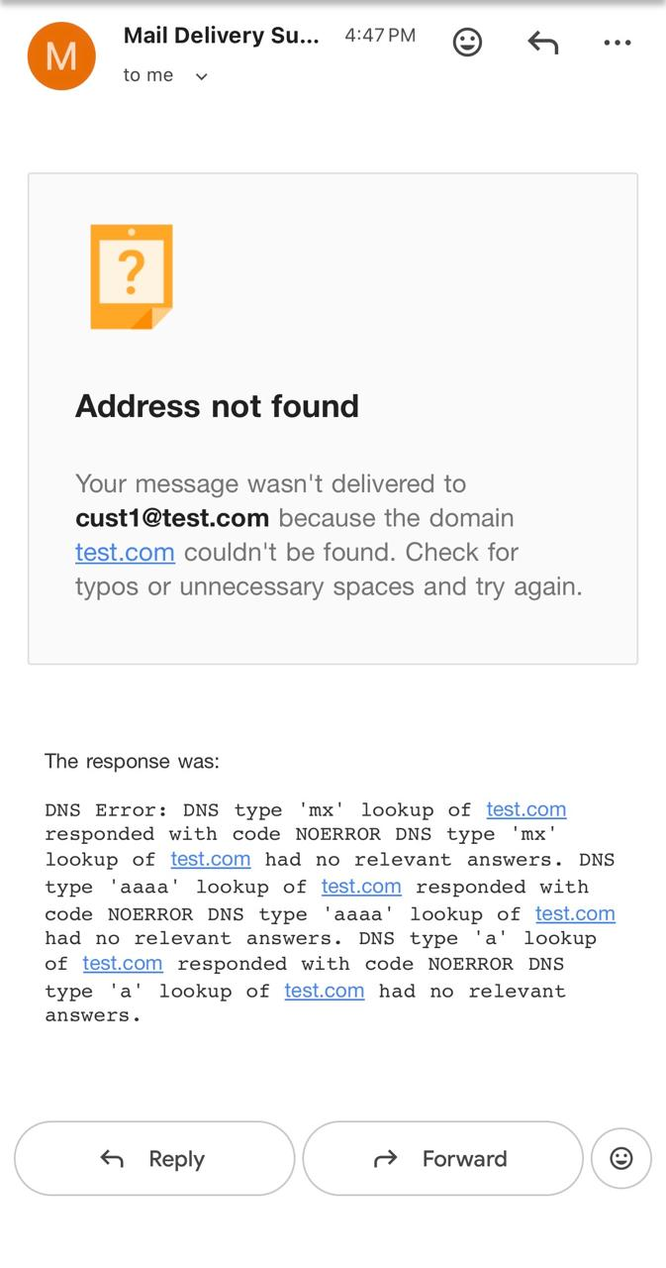
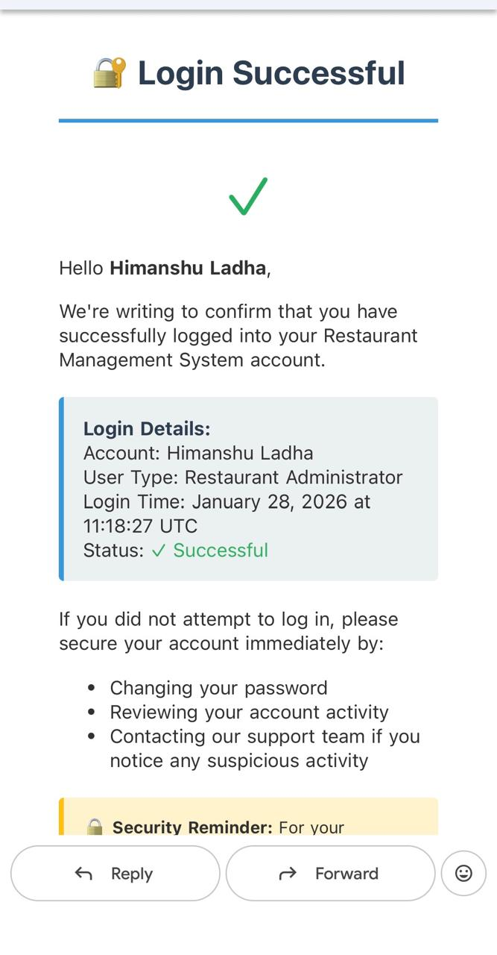
- If a login is detected from a different IP address or account, an alert email is immediately sent to the registered email address, notifying the user of a new or unusual login activity on their account.

29-01-2026
- Added the meal items categories wise in the restaurants for the demo with image.
- Make some unique changes.
- Solve some bugs in the project.

30-01-2026
- Make the routing changes in the Home page so the routing operations are perform better.
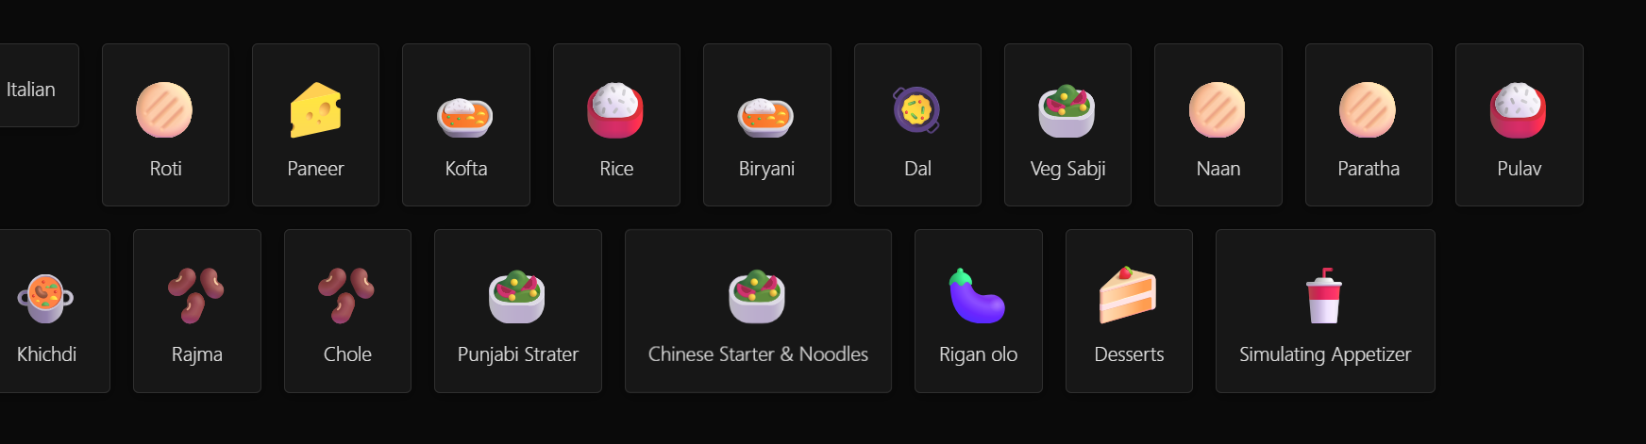
- When I click here the, ex:- On Roti then the roti items from all the restaurant will come in the route, then if we add to cart then it will ask for customer login. And back button click then the home page will come before it was not coming directing to customer section instead of not logged in.
- Same for all the cards in the home page. Set the proper navigation.

